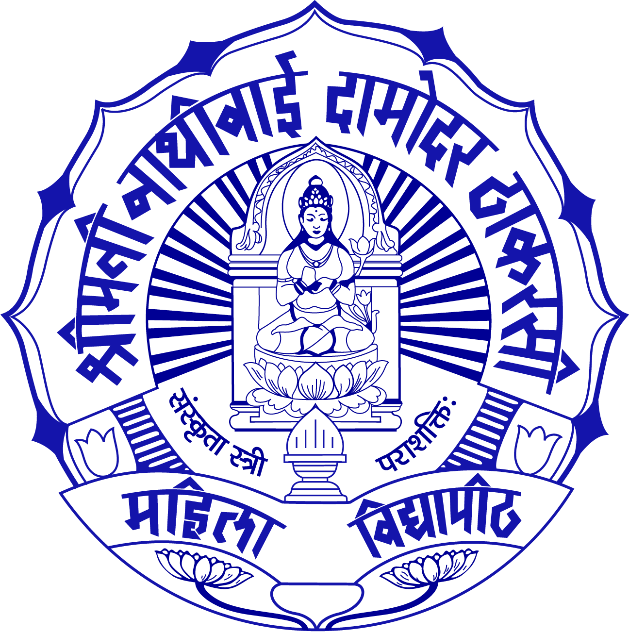
S.N.D.T. Women's University, Mumbai

ALL INDIA LEVEL COMMON ENTRANCE TEST (CET)

Personal Information

Name of Student

Father’s full name

Mother’s full name

Birth Place

Date of Birth

Address

State

Country

Tel / Mobile number

Email

Qualification

Qualification

School /College of Graduation

Grade

Percentage

Special Subject

Language Skills

Language Skill Speaking

Language Skill Writing

Language Skill Reading

Applying for Course
Programs covered under CET

Degree Program (4 years) Post Graduate Diploma (2 years)

B. Design PGD Fashion Retailing
Specialization in PGD Apparel Manufacturing &
- Fashion Design Merchandizing
- Fashion Communication
- Lifestyle & Accessories
- Textile Design
.

Colleges Offering Courses

001 - Satyam Fashion Institute, Noida
002 - School of Fashion Technology, Pune
003 - SDPS Women’s College, Indore

004 - Vanita Polytechnic,Varanasi

Preference for the college:

1st Preference

2nd Preference

3rd Preference

4th Preference

Computer Skills

Computer Application

Photoshop / Corel Draw

CET center

Demand Draft number

Date

Declaration: All the information given above is true to the based of my knowledge.

Signature of the Candidate

ELIGIBILITY CRITERIA & RESERVATION
CET – 60%, Qualifying Exam - 20%, Portfolio and Interview - 20%.
ELIGIBILITY FOR BACHELOR PROGRAMMES
40% weightage for General Ability and 60% weightage for Creative ability B. Design (Fashion Design / Fashion Design Specializations / Fashion Communication/ Apparel Manufacturing & Merchandising)
The +2 level examinations in the 10+2 pattern of examination of any recognized Central/State Board of Secondary Examination, such as Central Board of Secondary Education, New Delhi, and Council for Indian School of Certificate Examination, New Delhi.
OR
Any recognized Public School/Board/University Examination in India or in foreign countries equivalent to 10+2 system (Approved by AIU, New Delhi)
OR
ELIGIBILITY FOR POST GRADUATE DIPLOMA PROGRAMMES
P.G.DIPLOMA (Fashion Design / Fashion Retail Management / Apparel Manufacturing & Merchandising)
Bachelor Degree from a recognized Indian University in any discipline/Bachelor’s degree of any foreign university (Approved by AIU, New Delhi).
IMPORTANT NOTE
Candidates appearing for their qualifying examinations can also apply. Their admission, however, will be provisional and subject to obtaining the defined eligibility by 10th July, 2012. Proof of the candidates having successfully passed the qualifying examination will have to be produced at the time of joining the programme. In case, candidates do not produce the required documents by 10th July, 2012, their admission will be cancelled with the approved deduction of the fees paid (as prescribed by University).
Non fulfillment of the above conditions will automatically result in the cancellation of the provisional admission.
RESERVATION OF SEATS
The candidates belonging to Maharashtra & following categories i.e. SC/ST/NT/OBC/SCB are required to pay a draft of Rs. 500/- with the recent official cast proof for appearing CET examination.
-3-
A Reservation policy shall be applicable as per the state government rules.
B. The candidate belonging to the Reservation Category having domicile certificates of the concerned states shall be considered eligible for the concession prescribed by the concerned govt.

C. Scholarship and free ship shall be applicable as per the state govt rules.
D.50% concession against the fees for the application form of CET for the candidates’ belonging to the reservation category prescribed by the concerned state govt. subject to the attachment of necessary attested documentary proof of the caste certificates of the recent year along with the application form.

Reservation Policy : Government of Maharashtra:
Reservation – While giving admission to students the following reservation rules will apply.

I - Legal Reservation

- Scheduled Castes and Scheduled Castes converts to Buddhism - 13%
- Scheduled Tribe - 07%
- De-notified Tribes (A) – 03%
- Nomadic Tribes (B) - 2.5%
- Nomadic Tribes (c ) – 3.5%
- Nomadic Tribes (D) – 02%
- Other Backward Classes – 19%
Total – 50%

II - Social Reservation

Among the 50% seats for open category and 50% seats for reserved category, some seats as shown below will be reserved for following types of candidates (Internal Reservation).

- Candidates having a certificate from civil surgeon specifiying that the candidate is Physically Handicapped and deformity is 40% but is able to complete the course – 3%.
- Daughter /Wife of person in active/ retired military service – 2%
- One additional seat in each division for Kashmiri migrant.
The percentage will vary programme-wise which will be indicated at the time of declaration of results and is subject to availability of necessary infrastructure.
Reservation Policy: Government of UTTAR PRADESH
* SC – 22% * ST – 01% * OBC- (27%) The percentage will vary programme-wise which will be indicated at the time of declaration of results and is subject to availability of necessary infrastructure.
Reservation Policy: Government of MADHYA PRADESH
* SC – 15% * ST – 18% * OBC- (14%) The percentage will vary programme-wise which will be indicated at the time of declaration of results and is subject to availability of necessary infrastructure.
The qualifying candidates need to meet the eligibility and admission requirements of SNDT Women’s University.
Requirements of each category are as follows:
SC/ST CANDIDATES
Candidates applying under this reserved quota would have to produce a Caste/Tribe certificate from the Competent Authorities of the respective States/Union Territories/National Commission of Tribes.

OBC CANDIDATES
Candidates applying under this quota would have to produce a caste certificate from the Competent Authorities of the respective States/Union Territories along with a certificate that they do not belong to the creamy layer.
IMPORTANT NOTE
The candidates applying for the entrance examination should ensure that they fulfill all the eligibility criteria for admission to the examination. If on verification at any time before or after the Written Test and Interview, it is found that candidate does not fulfill THE eligibility criteria, her candidature for the examination shall stand cancelled without any notice or further reference.
Admission Process
Please mention the availability of application form at the web link of SNDT
The Candidate can choose any one of the following programmes:
A. B. Design with following specializations (4 Years )
a. Fashion Design b. Fashion Communication c. Lifestyle d. Textile Design
B. PGD Fashion Retail Management - 2 years
C. PGD Apparel Manufacturing & Merchandising - 2 years
D. PGD Fashion Design - 2 years
3. The admission weight age to a P.G./ U.G. programme is- CET – 60%
Qualifying Exam - 20%
Portfolio and Interview - 20%
- The CET candidates are required to attend the counseling/ Interview session on a 3rd June at the main college centre to which students have given 1st preference. The schedule of the counseling for final allotment of courses would be displayed on the SNDTCET web site as well as the student will be informed via e –mail (It is essential to provide proper e-mail ids)... Candidates whose names appear in the list put on the website but have not received the invitation for counseling should also appear for counseling on the counseling date(s) notified.

- If the candidate remains absent on the date and time specified for the counseling session or does not deposit the fee through Bank Demand Draft, the candidature will be cancelled and the next candidate in the final merit will be called immediately

- A candidate who reports later than the date and time when her rank in the merit list required her to do so, she will be considered for admission against the seats that are available at that point of time in various programmes. She will not be eligible and will not be considered against a seat that would have ordinarily gone to her on the basis of merit.

- The candidates are required to get all original certificates and a set of attested certificates at the time of interview along with the portfolio.

- The candidates are advised to join the programme offered at the allotted college within ten days of commencement of the programme, failing which, their admission will stand cancelled without any intimation and the tuition fee paid shall be forfeited. The vacant seat shall be offered to the waitlisted candidates in the order of merit.

UNIVERSITY AFFILIATED COLLEGES AND SEATS AVAILABLE

1. School of Fashion Technology, Pune
Maharshi Karve Stree Shikshan Samstha’s School of Fashion Technology, Karve Nagar, Pune another affiliated college of S.N.D.T. situated in Pune is a state of art college which has established its benchmark in the field of fashion on National as well as International level.
Programmes: Degree Course
1. B. Design with specializations: - 4 Years Seats - 120
a. Fashion Design.
b. Fashion Communication.
c. Textile Design.
d. Lifestyle.
Postgraduate (Diploma Course):
1. Fashion Retail Management - 2 Years Seats- 30

2. S.D.P.S Women’s College, Indore
S.D.P.S Women’s college, Indore was set up in the year 2003 under the aegis of Smt. Dhairya Prabhadevi Sojatia women’s welfare society with an affiliation to the renowned S.N.D.T .Women’s University, Mumbai. The college offers specialized and professional education for women, thus opening for them, lucrative career options and making them realize the concept for self-dependence, with exposure to internationals and national project work.
Programmes: Degree Course
1. B. Design - 4 Years
a. Fashion Design - Seats - 40

3. Satyam Fashion Institute, Noida
SFI offers professional education programmes at Under Graduate and Post Graduate levels. SFI is a unique institution with many problem-solving capabilities, depths of intellect and a time-tested, creative educational culture in promoting design competencies and setting standards of design education. The rigorous development of the designer’s skills and knowledge through a process of ‘hands on minds on’ is what makes the difference.
Programmes: Degree Course
1. B. Design with specializations: - 4 Years Seats - 120
a. Fashion Design.
b. Fashion Communication.
c. Textile Design.
d. Lifestyle.
Programmes: Postgraduate (Diploma course)
1. PGD Apparel Manufacturing & Merchandising (2 years) Seats-40
2. PGD Fashion Design (2 years) Seats - 40

4. Vanita Polytechnic College, Lahurabir,Varanasi
Programmes: Degree Course
1. B. Design - 4 Years Seats - 60
a. Fashion Design.
b. Fashion Communication.

